Pokhara University

Level: Bachelor | Semester – Fall | Year : 2011
Programme: BE |  | Full Marks: 100
Course: Engineering Mathematics II |  | Pass Marks: 45
 |  | Time : 3hrs.

Candidates are required to give their answers in their own words as far as practicable.
The figures in the margin indicate full marks.

Attempt all the questions.

 | - Define shortest distance between two skew lines in space. Find the length and equation of shortest distance between the lines 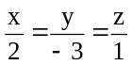and 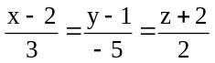.  - Find the equation of sphere through the circle x² + y² = 4, z = 0 and is cut by the plane x + 2y + 2z = 0 in a circle of radius 3. | 7  8
 | - If the sum of the dimension of a rectangular swimming pool is given, prove that the amount of water in the pool is maximum when it is a cube.  - State and prove Euler's theorem for homogeneous function of two variables.  If U = log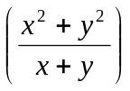, prove that 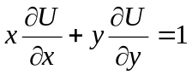 | 7  8
 | - Sketch the region of integration and evaluate by interchanging the order of integration  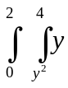cosx² dxdy  - Find the volume of the solid whose base is the region in the xy-plane that is bounded by the parabola y = 4 - x² and line y = 3x while the top of the solid is bounded by the plane z = x+4. | 7  8
 | - Solve the differential equation 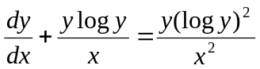  - Solve 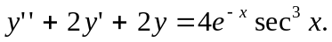 | 7  8
 | - Solve by power series method y" + y = 0.  OR  Define Bessel function of the first kind of order n. Show that 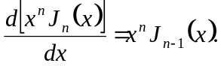  - Solve the following initial value problem y"- 4y'+5y = 0, y(0) = 1, y'(0) =2 | 8  8  7
 | - Evaluate the following :  - L(t² cos wt)  - L⁻¹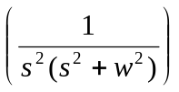  - Solve the following initial value problem by using Laplace transform  y" + 2y' + 5y = 0, y' (0) = - 4, y(0) = 2 | 8  7
 | Answer the following questions:  - Find the Laplace transform of unit step function U_{a} (t)  - Find the angle between following pair of planes: 2x + 3y + 5z = 0 and x- 2y+z =20  - Integrate: 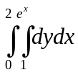  - Verify Euler’s theorem for the function 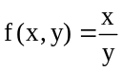  - Solve :- 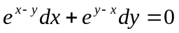 | 2  2  2  2  2

